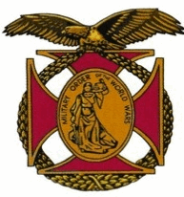

Meeting of the General J. P. Holland Chapter of the MOWW
STAFF MEETING
June 23rd, 2016

In attendance were
  - Commander – Nick Herbka,
  - Sr VP - Cal Swepston,
  - Jr VP - Earl Wentworth
  - Adjutant – Tom Lettington

- The San Diego Chapter will host the 2016 Combined Christmas Party at the Bernardo Heights Country Club. Moe details later
- The Chapter investment in the CA REIT (Real Estate Investment Trust) offered by the “Rich Uncle” Group is doing quite well, earning 7.5% annual return and soon to earn substantially more. The Staff agreed to put $20,000 money in the REIT.
- General discussion of the importance of the YLC
- The Bernardo Heights Country Club will be closed the first weekend in October so our regular monthly meeting will be changed to the second Saturday.
- The Staff discussed and approved the donation of $100 to the Orange Glen JNROTC program in recognition for their volunteering to carry the MOWWW Flag in the RB Spirit of the Fourth Parade on July 4th.
- Carl will invite the Commanding Officer of Beach Master Unit 1 to be our speaker at the September Chapter Meeting.

